Application Number | 07/2018/3291/FUL
Address | Unit 3  143 Station Road  Bamber Bridge  Preston  Lancashire  PR5 6LA
Applicant | Mr Mark Bentham

Development | Change of use of former shop (Class A1 retail) to drinking establishment (Class A4 Drinking Establishment)
Officer Recommendation  Officer Name | Approval with Conditions  Mrs Janice Crook

Date application valid | 25.05.2018
Target Determination Date | 20.07.2018
Extension of Time | N/A
Location Plan

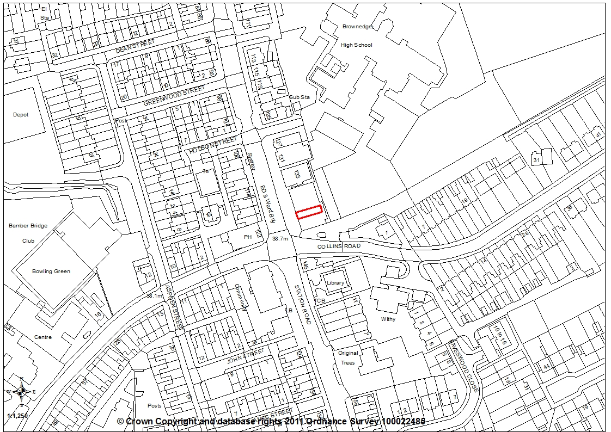

- Report Summary

1.1 This application is for a change of use of a vacant A1 retail premises to a drinking establishments within the A4 Use Class. The proposal is for a micro pub serving craft ales.

1.2 The site is outside of the district centre of Bamber Bridge in a mixed use area were commercial and residential properties are alongside each other. The site is also close to the busy crossroads junction of Station Road/Collins Road and Brownedge Lane.

1.3 The premises has a lawful use for retail and is in a highly sustainable location. County Highways have raised no objections and consider the proposal should have a negligible impact on highway safety and capacity in the immediate vicinity. Environmental Health consider there is only limited potential to impact on neighbouring properties and therefore recommend conditions be imposed. The application is recommended for approval subject to the imposition of conditions.

- Site and Surrounding Area

2.1 The application relates to the commercial property Unit 3, within a terrace of commercial premises at 143 Station Road. The terrace is located on the eastern site of Station Road in Bamber Bridge, close to the crossroads junction of Station Road, Collins Road and Brownedge Lane. The unit has previously been used as an A1 retail premises for domestic appliances.

- Planning History

- 07/1983/0457 Alterations to shop front. Approved 24/08/1983
- 07/1986/0524 New shop front. Approved 22/10/1986

- Proposal

4.1 The application proposes the change of use of Unit 3 from A1 Retail to a drinking establishment within Use Class A4. No alterations are proposed to the property. Internally the proposal provides for a storage area to the rear of the premises with WC’s opposite, a square bar area with seating around, two areas of linear seating, one to the front and one to the left hand side and tables and chairs in the remaining floorspace area.

- Summary of Publicity

5.1 Neighbouring properties were notified and a site notice posted with two letters of representation being received, one objecting to the proposal on the following grounds:

- Will cause anti-social behaviour in the area
- In close proximity to a school
- There are enough pubs and off licences in the area

5.2 The second letter supports the application, commenting:
- good to see that empty shops being used for new businesses
- person involved in the business is a local person
- community should support local businesses

- Summary of Consultations

6.1 County Highways consider the proposal should have a negligible impact on highway safety and capacity within the immediate vicinity of the site and therefore have no objections.

6.2 Environmental Health comment that the proposed development has the potential, although limited, to adversely impact on neighbouring land uses and as such conditions are required to restrict the use of live music, recorded music, no outside use and a restriction on the time of deliveries.

- Policy Background

7.1 Policy B1: Existing Built-up Areas permits development proposals for the re-use of undeveloped and unused land and buildings, or for redevelopment, provided that the development complies with the requirements for access, parking and servicing; is in keeping with the character and appearance of the area; and will not adversely affect the amenities of nearby residents.

7.2 Policy F1: Parking Standards requires all development proposals to provide car parking and servicing space in accordance with the parking standards adopted by the Council. In general, parking requirements will be kept to the standards as set out unless there are significant road safety or traffic management implications related to the development of the site. The parking standards should be seen as a guide for developers and any variation from these standards should be supported by local evidence in the form of a transport statement.
Where appropriate, some flexibility will be factored into the standards in relation to the specific local circumstances.

7.3 Core Strategy Policy 26: Crime and Community Safety aims for reduced levels of crime and improved community safety through a number of measures, as follows:
- Working with the police, community safety partnerships and other agencies to co-ordinate analysis and action.
- Encouraging the inclusion of Secured by Design principles in new developments.
- Providing adequate leisure and community facilities or activities, particularly in high crime areas, and especially for young people.
- Aiming to achieve a complementary mix of uses in the City and key service centres with appropriate controls over entertainment uses, taking account of the local authorities’ Statement of Licensing policies.

- Material Considerations

8.1 The application property is within a row of 6 shops, all of uniform size and design. Adjacent properties include an Age Concerns shop and hot food takeaway to the south and a florist, laundry and accountants to the north with a Spar convenience store beyond. On the opposite side of Station Road is the Withy Arms public house with four residential properties, a hairdressers and tanning studio. To the rear is the Brownedge St Mary’s RC High School. The area is therefore considered to a mixed use area.

8.2 The proposal is for a change of use from an A1 retail premises, last used by Northwest Domestics, a domestic appliances retail premises, to a drinking establishment within the A4 use class. The proposal is for a micro pub and the submitted supporting statement indicates:

“We are submitting this application to turn the empty unit that was formerly North West Domestic Appliance centre into a Micro Pub. We are three friends that have lived in the local area all our lives and are passionate about real ale and craft beers and want to create a small but welcoming venue that serves a variety of locally made craft ales. We have chosen this location as it will be convenient for local residents to call in but it should have no adverse impact on residents as it is in an existing predominantly commercial zone.

The pub will employ people from the local community and we seek to compliment other local business for mutual benefit. We are aware that two other Micro Pubs are due to open in Bamber Bridge (Brig N Barrell and Weaver's Arms) which we see as a positive as this will offer local residents multiple places to visit and potentially encourage customers from other surrounding areas.

Given the number of public houses that have closed in Bamber Bridge in recent years we see this as a positive addition to the area and it will complement the other businesses in the near vicinity comprising multiple takeaways, off licences, taxi ranks and other drinking establishments.

Our plan is to invest our own money in creating an updated and inviting interior but with a low key and complimentary exterior that fits well with the recent investments and regeneration in Bamber Bridge.”

8.3 The principle of this proposal is therefore in accordance with Policy B1 which permits development proposals for the re-use of undeveloped and unused land and buildings, or for redevelopment. However, this is providing the development complies with the requirements for access, parking and servicing. The site does not have its own dedicated off-street parking provision and there are no public car parks in the immediate vicinity of the site. The adopted parking standards are a maximum requirement and require one parking space per 5 square metres of public floor space for a drinking establishment outside of the district centre compared to 1per 20 square metres for non-food retail floorspace. Therefore the level of parking required would amount to 10 spaces

8.4 However, County Highways do not raise parking as an issue, commenting this is an existing retail unit without parking. The site is in a highly sustainable location. The proposed use is unlikely to generate any more demand for parking than the existing use, and there is an argument that as a licenced premises a significant proportion of customers are not likely to drive.

8.5 Additionally, County Highways are of the opinion that the proposals should have a negligible impact on highway safety and highway capacity within the immediate vicinity of the site and has no objections to the application.

8.6 Given that the premises is on Station Road with good public transport access, that no dedicated parking exists for the existing retail premise and that County Highways do not consider the proposed use will not increase demand for parking, then, on balance, the proposal is considered acceptable in terms of parking.

8.7 To be in compliance with Policy B1, the application proposal must also be in keeping with the character and appearance of the area. The proposal does not include any external alterations and therefore there will be no impact on the street scene in which the property is located.

8.8 Finally, the proposal must not adversely affect the amenities of nearby residents. Four residential properties are located on the opposite side of Station Road within a terrace of residential and commercial. It is unclear whether there is any first floor residential accommodation above the commercial premises. The corner property is the Withy Arms public house with the opposite end of the terrace being a further residential property. The commercial premises are mainly day time uses.

8.9 Along the same side of Station Road are a convenience store and three hot food takeaway premises, open until 11pm (2 premises) and midnight. The proposed drinking establishment proposes opening hours of 12 noon until 23.30 Monday to Friday and 12 noon until midnight on Saturday and 12 noon until 23:00 on Sunday and Bank Holidays. These proposed hours of opening are in line with other premises in the area and it is therefore considered this aspect of the proposal will not unduly impact on neighbouring residents in terms of residential amenity, particularly as the area is in mixed use.

8.10 One letter of objection has been received from the adjacent convenience store. The objector comments that by allowing this bar to open it will cause more anti-social behaviour in the area. The convenience store has already had window smashed allegedly due to drunken behaviour and fighting, with the police having to be called. However, there is no evidence to demonstrate that the proposed drinking establishment will create anti-social behaviour. The proposal is for a micro pub operated by three local friends who are passionate about real ale and craft beers and want to create a small but welcoming venue that serves a variety of locally made craft ales. It cannot be automatically assumed that this type of premises would attract anti-social behaviour.

8.11 Additionally, the location has been chosen as it will be convenient for local residents. Environmental Health have recognised that the proposal has the potential to adversely impact on neighbouring land uses but consider this is limited. With the inclusion of the conditions recommended by Environmental Health, there should be no adverse impact on residents, particularly as it is in a predominantly commercial zone.

8.12 The objector also considered that there are enough pubs and off licences in the area another one is not needed. However, competition is not a material planning consideration.

- Conclusion

9.1 For the reasons outlined above, the application is considered to be policy compliant and is recommended for approval subject to the imposition of conditions.

- Recommendation

10.1 Approval with Conditions.

- Recommended Conditions

1. The development hereby permitted must be begun not later than the expiration of three years beginning with the date of this permission.
REASON: Required to be imposed pursuant to Section 91 of the Town and Country Planning Act 1990.

2. The development, hereby permitted, shall be carried out in accordance with the submitted approved plans Dwg “Proposed Plan and Front Elevation” (un-referenced)
REASON: For the avoidance of doubt and to ensure a satisfactory standard of development

3. The use of the premises hereby approved shall be restricted to the hours as applied for of 12:00 Noon until 23:30 Monday to Friday; 12:00 Noon to Midnight on Saturday and 12:00 Noon to 23:00 on Sundays and Bank Holidays,
REASON: In the interests of the amenities of adjoining residents and to accord with Policy 17 in the Central Lancashire Core Strategy

4. No deliveries or waste collection shall be received by the site between the hours of 22:00 and 07:30 Monday to Friday, 09:00 and 13:00 Saturdays. No deliveries or waste collection shall be received on Sundays or nationally recognised Bank Holidays.
REASON: In the interests of the amenity of the nearby residents in accordance with Policy 17 of the Central Lancashire Core Strategy.

5. No live music shall be played at the venue.
REASON: In the interests of the amenity of the nearby residents in accordance with Policy 17 of the Central Lancashire Core Strategy.

6. Prior to first use of the premises herby approved, a sound limiter device shall be fitted. Details of the device shall be submitted to the local planning authority, once agreed all amplified audio shall be played through the limiter. The limiter shall be set to ensure that the resulting sound cannot be heard at neighbouring properties. On the receipt of any complaints to the local authority relating to sound emissions from the development then the limiter shall be set to the requirements of the Environmental Health Department of the local authority.
REASON: To safeguard the amenities of neighbouring properties in accordance with Policy 17 of the Central Lancashire Core Strategy.

7. There shall be no external seating or patio heaters outside the venue.
REASON: In the interests of the amenity of the nearby residents in accordance with Policy 17 of the Central Lancashire Core Strategy.

12. Relevant Policy

B1 Existing Built-Up Areas
F1 Car Parking

26 Crime and Community Safety (Core Strategy Policy)

